

BUILDING STRUCTURES [ARC 2522] [ARC 2523]
PROJECT 2: Extension of a R.C. Structure

Chosen Existing R.C. Building: No. 2, Jalan USJ 2/6G, UEP Subang Jaya, Mukim Damansara, Daerah Petaling, Selangor Darul Ehsan

Name: LEE QIN NI
Student ID: 0317554
Tutor: Ms Ann See Peng

Quantify Dead Loads Acting on Structure  First Floor  Toilet:  Slab thickness = 150mm  Slab self-weight = 0.15m x 24 kN/mᵌ  = 3.6 kN/m²  Balcony:  Slab thickness = 150mm  Slab self-weight = 0.15m x 24 kN/mᵌ  = 3.6 kN/m²  Office:  Slab thickness = 150mm  Slab self-weight = 0.15m x 24 kN/mᵌ  = 3.6 kN/m²  Photo Equipment Storage:  Slab thickness = 150mm  Slab self-weight = 0.15m x 24 kN/mᵌ  = 3.6 kN/m²  Veranda:  Slab thickness = 150mm  Slab self-weight = 0.15m x 24 kN/mᵌ  = 3.6 kN/m²  Dark Room:  Slab thickness = 150mm  Slab self-weight = 0.15m x 24 kN/mᵌ  = 3.6 kN/m²  Brick Wall Weight  =Wall Height x Tickness x Density  =3.3 m x 0.15m x 19 kN/mᵌ  =9.405 kN/m  Beam Self Weight  (assume that initial beam size 150mm x 300mm)  = Beam size x Concrete Density  = 0.15 m x 0.3 m x 24 kN/mᵌ  = 1.08 kN/m  Ground Floor  Brick Wall Weight  =Wall Height x Tickness x Density  =3.0 m x 0.15m x 19 kN/mᵌ  =8.55 kN/m | Lobby:  Slab thickness = 150mm  Slab self-weight = 0.15 m x 24 kN/mᵌ  = 3.6 kN/mᵌ  Gym:  Slab thickness = 150mm  Slab self-weight = 0.15 m x 24 kN/mᵌ  = 3.6 kN/mᵌ  Quantify Live Loads Acting on Structure  (According to 4th schedule of UBBL for live load according to the function of the space.)
  Ground Floor  Lobby:  3.0 kN/m²  Gym:  2.5 kN/m² | First Floor  Toilet :  2.0 kN/m²  Balcony:  1.5 kN/m²  Office:  1.5 kN/m²  Veranda:  1.5 kN/m²  Dark Room:  2.0 kN/m²

Extension Proposal
Ground Floor Extension
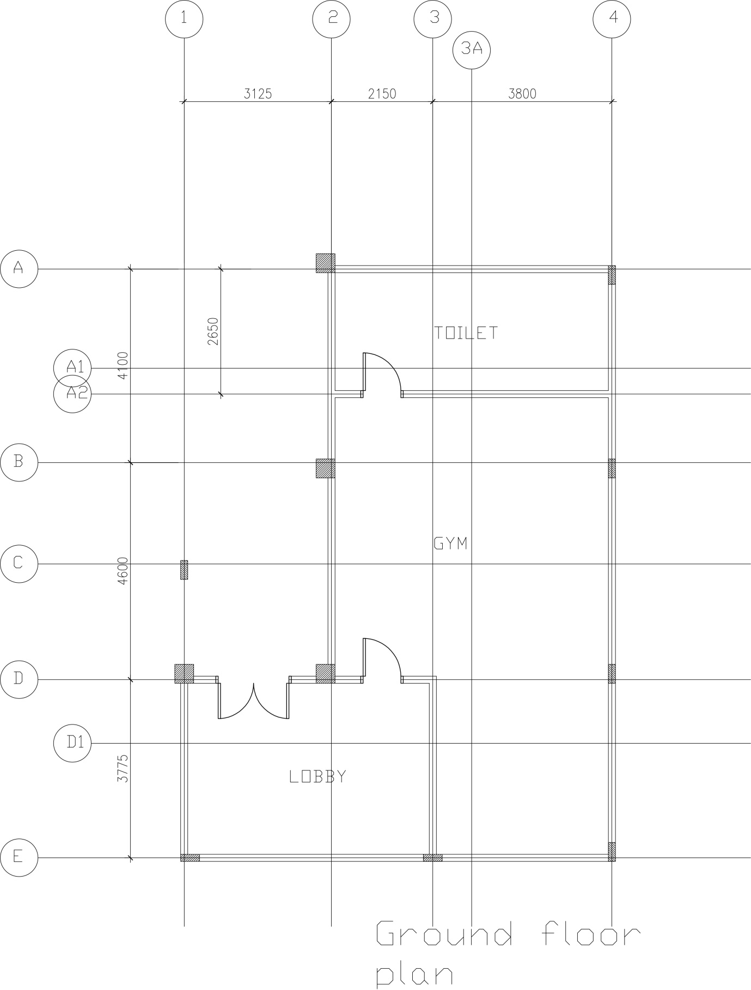

First Floor Extension
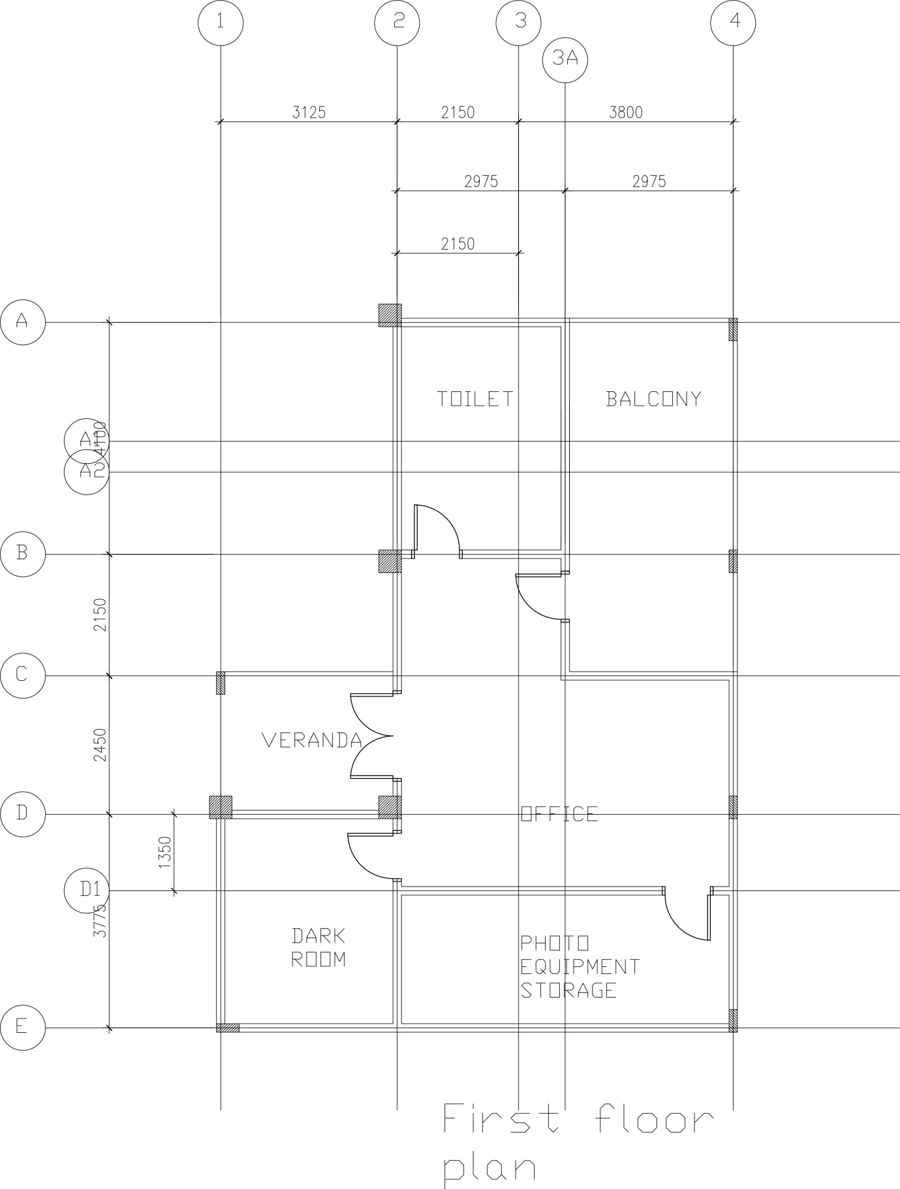

Roof Level Extension
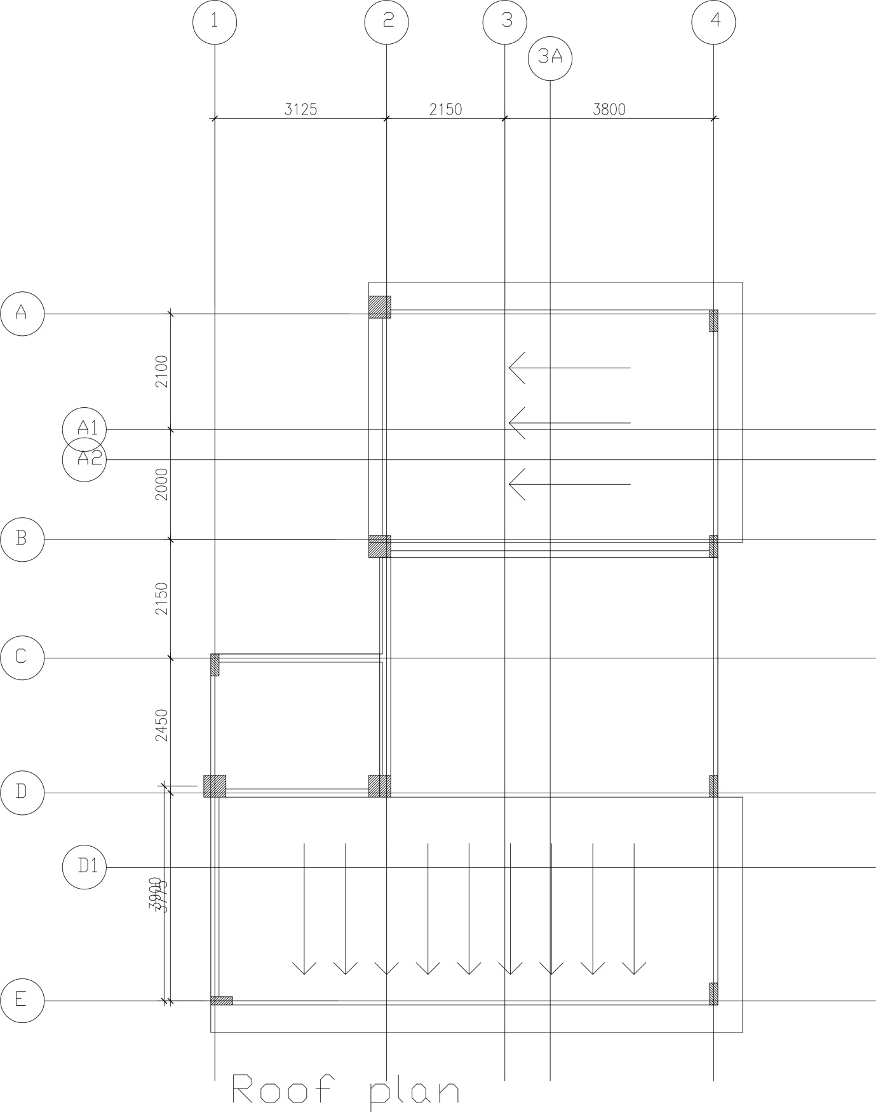

Ground Level Structural Floor Plan
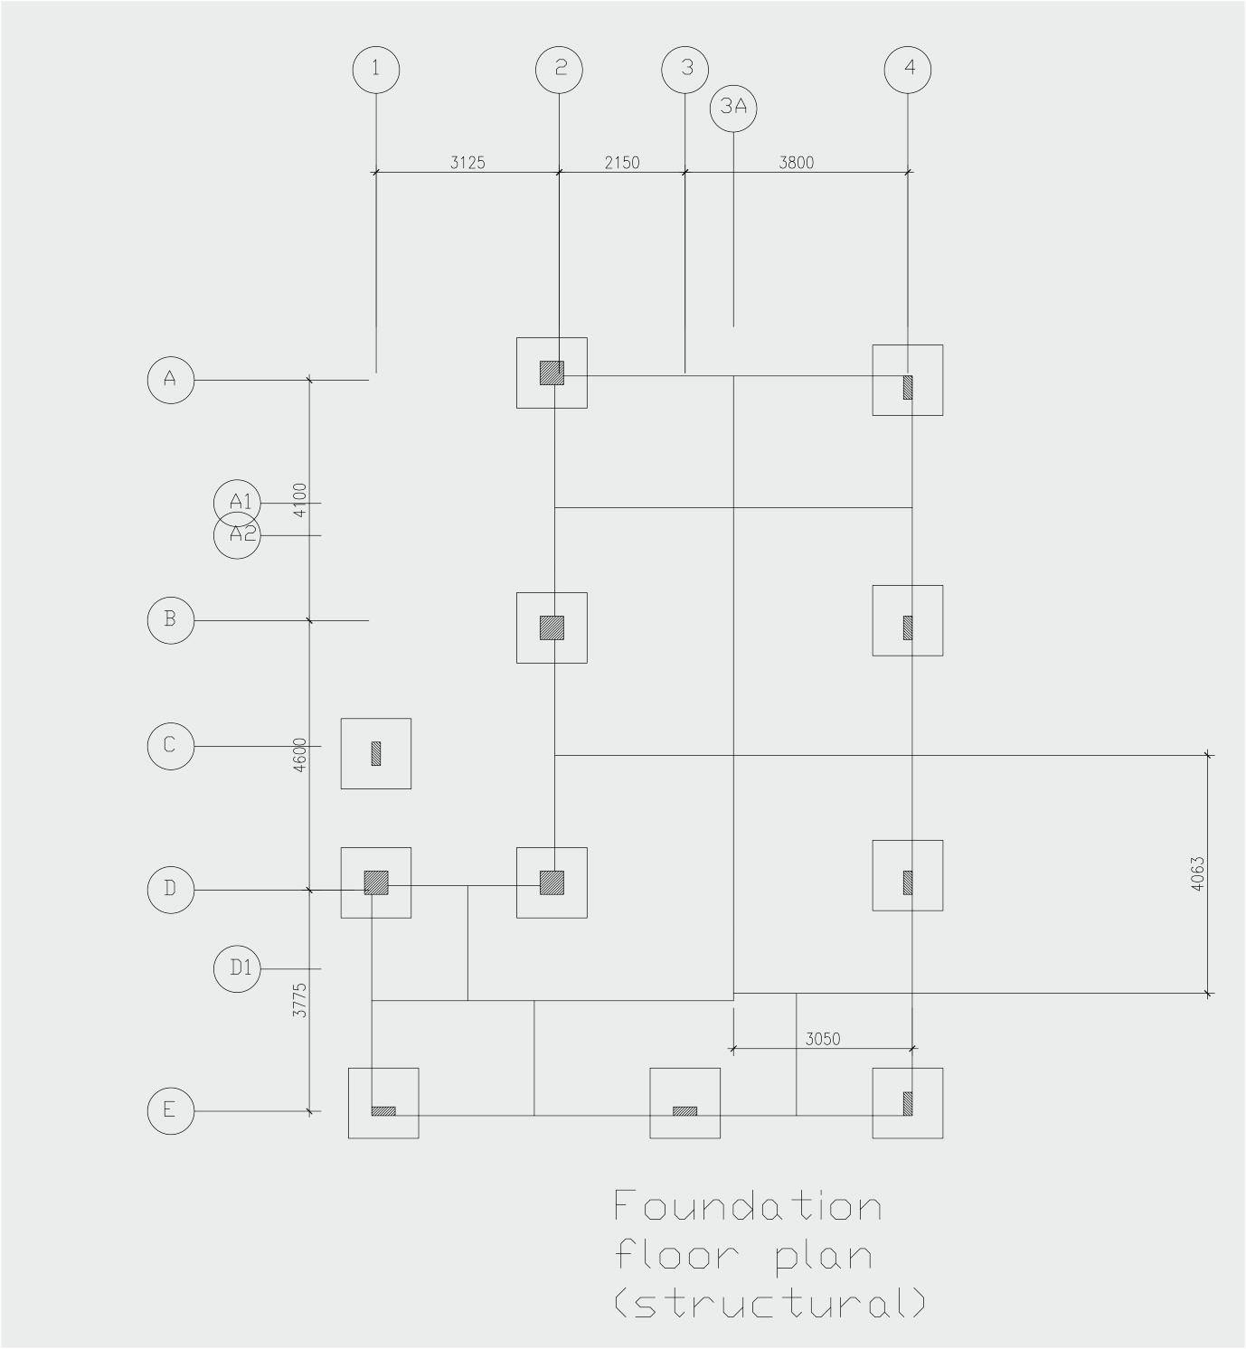

Ground Floor Level Structural Floor Plan
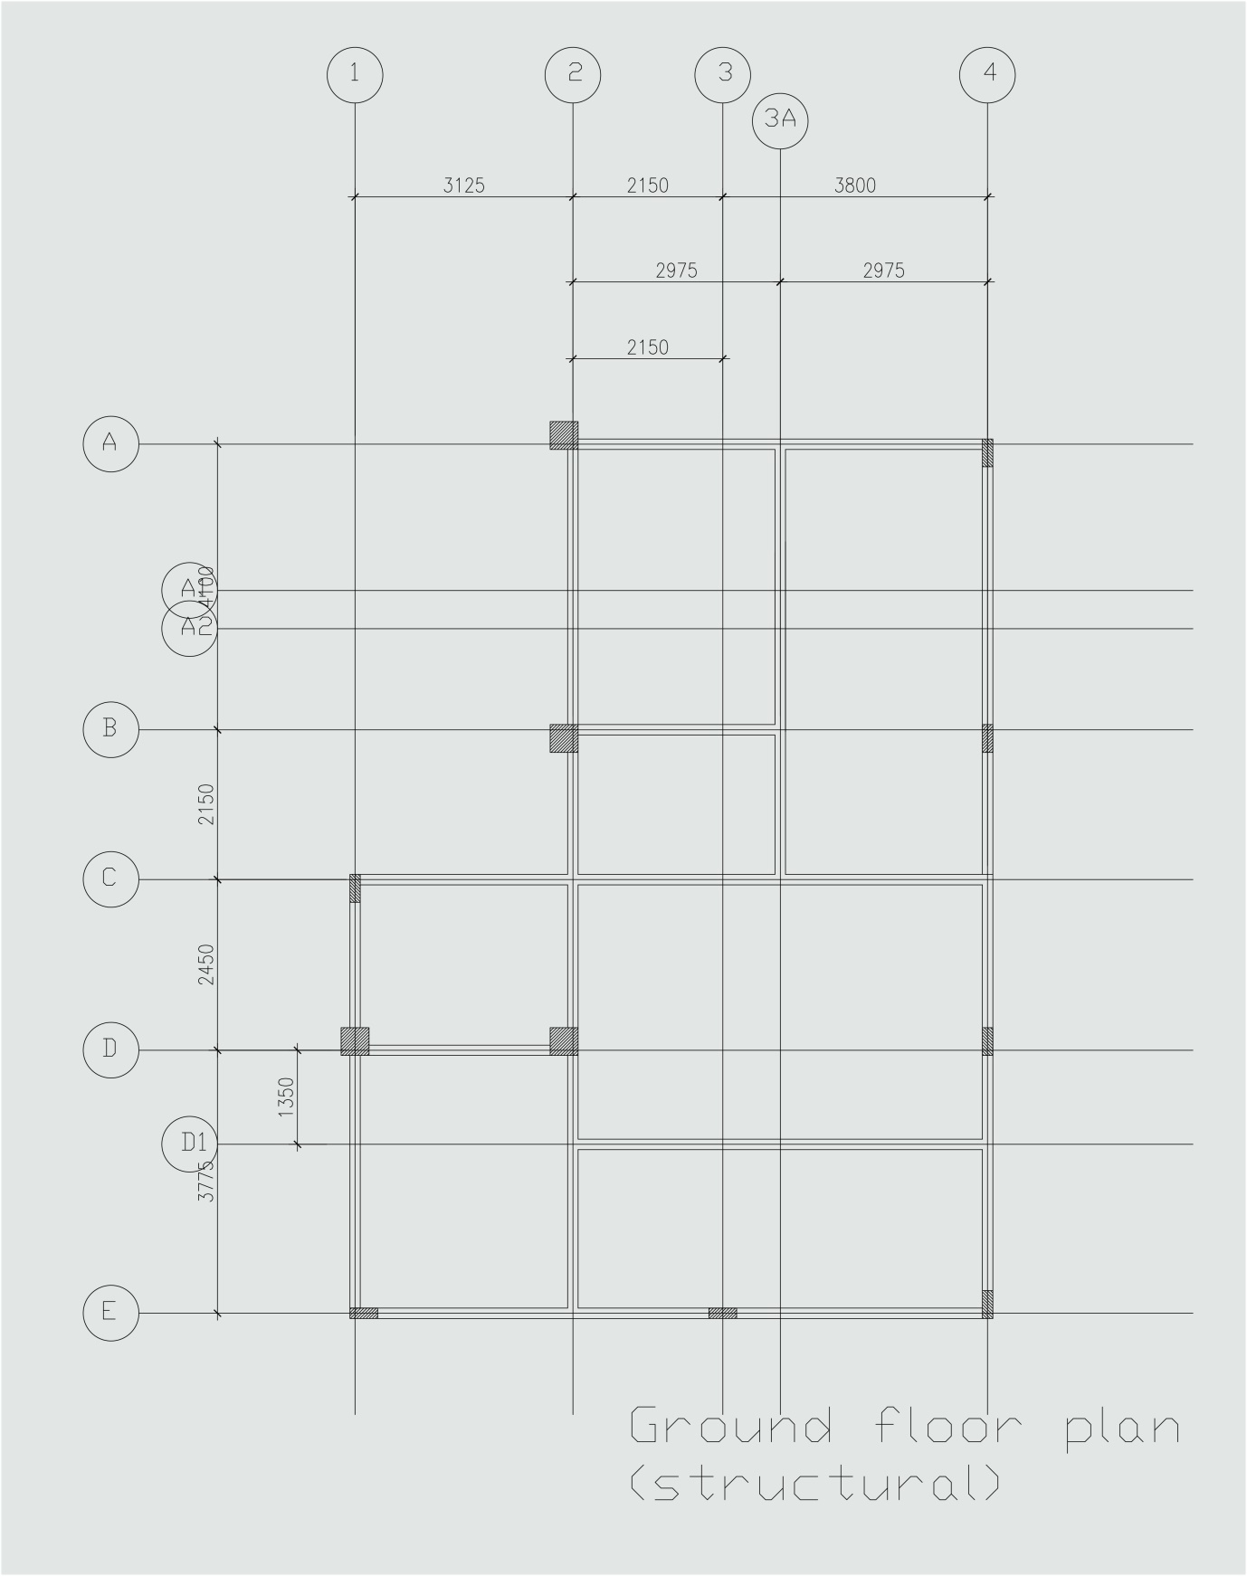

First Floor Level Structural Floor Plan
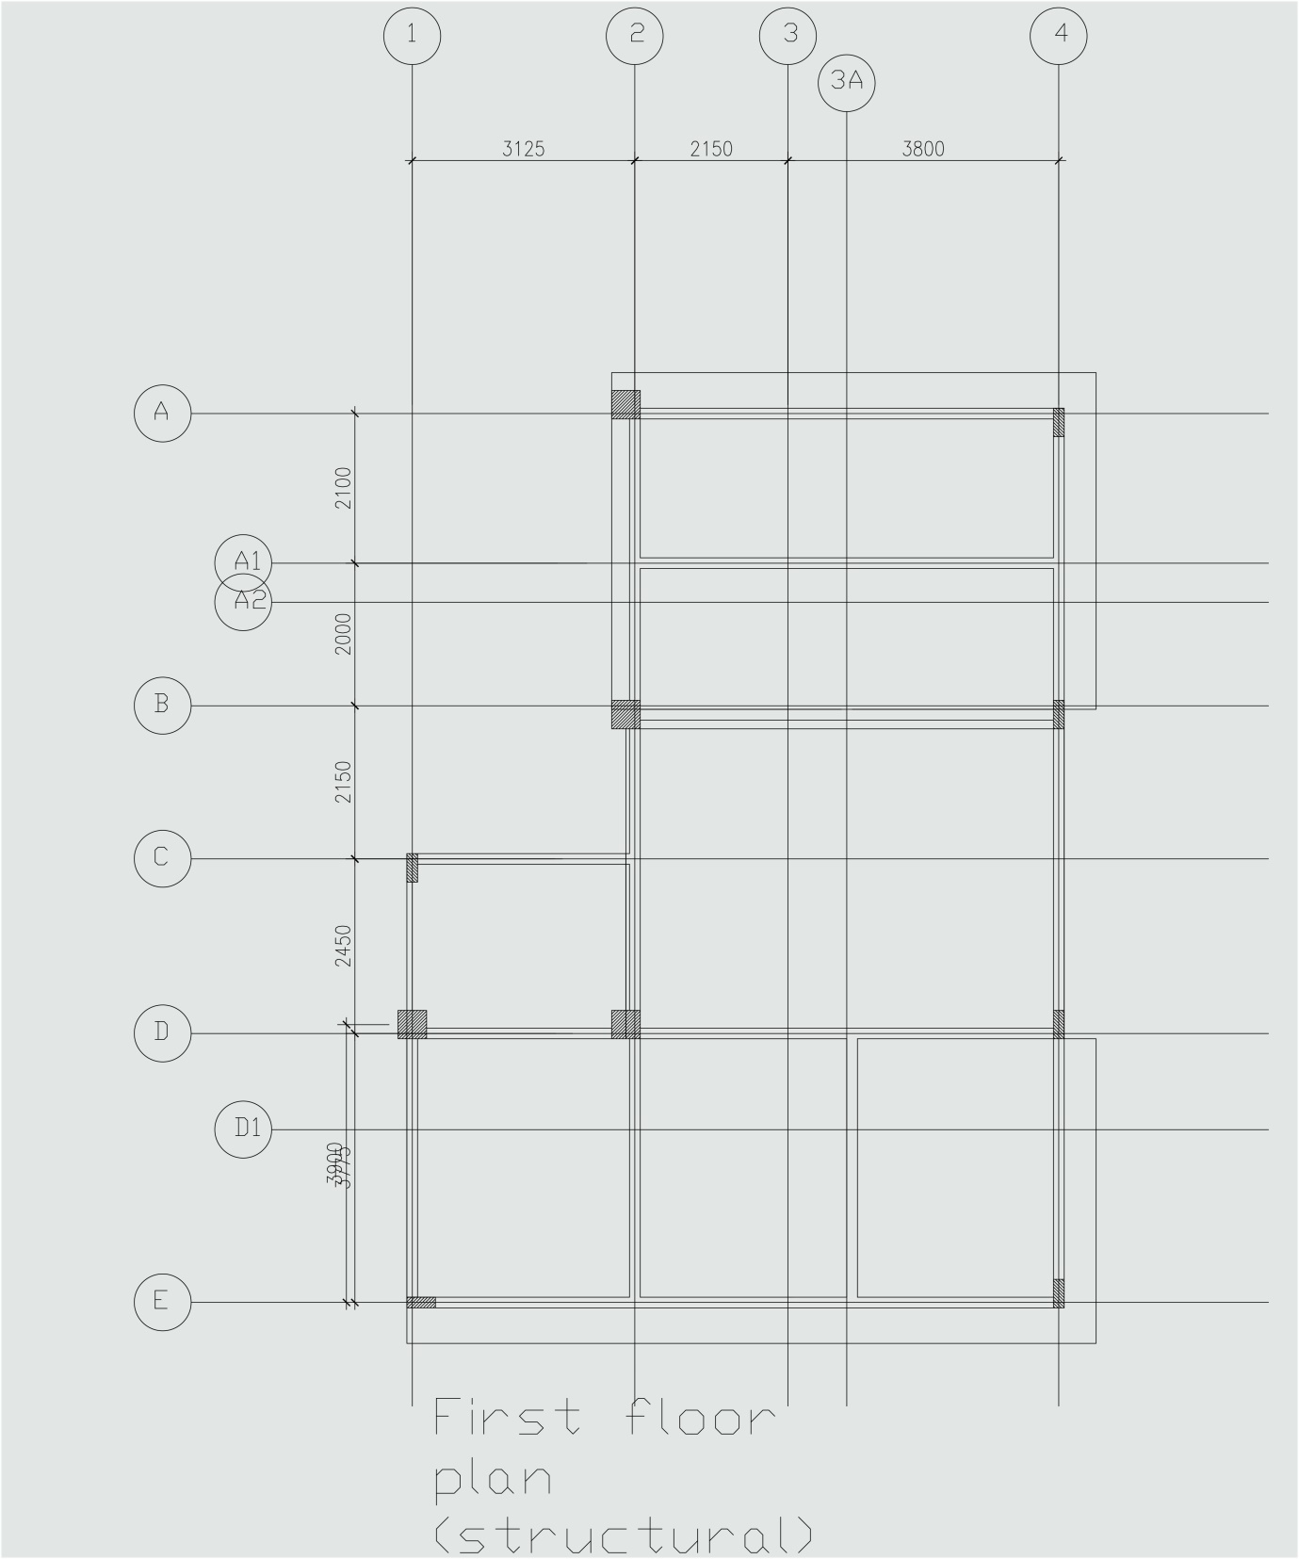

Identify One Way or Two Way Slab
Indicating the Distribution or Load from Slab to Beam

L_{y} = Longer side of slab
L_{x} = Shorter side of slab
When L_{y} / L_{x} > 2, it is a one way slab.
When L_{y} / L_{x} < or = 2, it is a two way slab.

Toilet
Slab 2-3A / A-B
= 4100/2.95
= 1.38 < 2 [Two way slab]

Balcony
Slab 3A-4 / A-C
= 6.25/2.975
= 2.1 > 2 [One way slab]

Office
Slab 2-3A / B-C
= 2.975/2.15
= 1.38 < [Two way slab]
Slab 2-4 / C-D1
= 5.95/3.8
= 1.57 < 2 [Two way slab]

Veranda
Slab 1-2 / C-D
= 3.125 / 2.450
= 1.28 < 2 [Two way slab]
Dark Room
Slab 1-2 / D-E
= 5.125 / 3.125
= 1.64 < 2 [Two way slab]
Photo Equipment Storage
Slab 2-4 / D1-E
= 5.95 / 3.775
= 1.58 < 2 [Two way slab]

Load Distribution Diagram (Ground Level Structural Plan)
To identify how much load would be transferred from the slab to each adjacent beam.
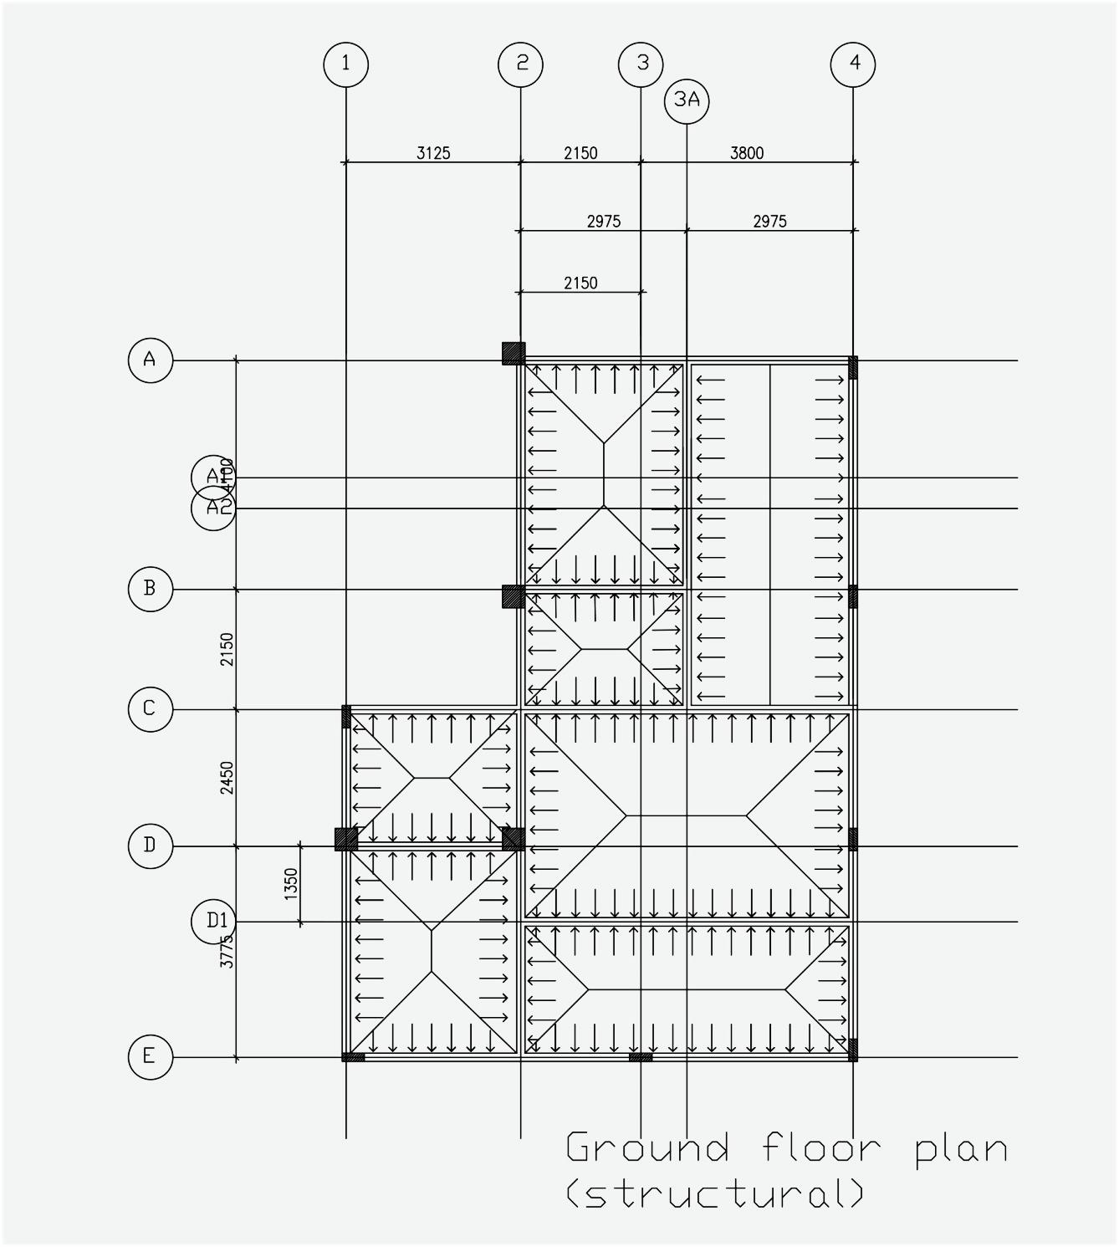

Beam Analysis Calculation
Ground Floor Beam, 2-4 / D1
- Carries self-weight – Dead load
- Slab Dead Load & Live Load
- 2-4 / C-D1
- 2-4 / D1-E

- Beam self-weight = Beam size x concrete density
= 0.15 m x 0.30 m x 24 kN/m³
= 1.08 kN/m
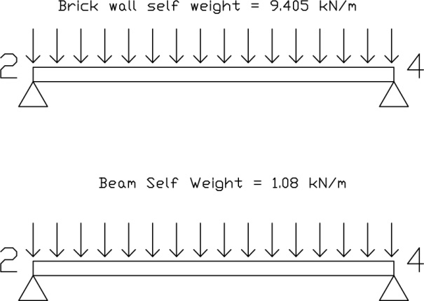
- Brick wall weight = Wall height x thickness x density
= 3.3 m x 0.15 m x 19 kN/m³
= 9.405 kN/m
Dead load on slab 2-4 / C-D1 [Two way slab]
Load is transferred to beam 2-4 / D1 in a trapezoidal form. Convert the trapezoidal load into UDL.
Dead Load from slab 2-4 / C-D1 = Dead load on slab x (L_{x}/2)
= 3.6 kN/m² x (3.8/2)
= 6.84 kN/m

Dead load on slab 2-4 / D1-E [Two way slab]
Load is transferred to beam 2-4 / D1 in a trapezoidal form. Convert the trapezoidal load into UDL.
Dead Load from slab 2-4 / D1-E = Dead load on slab x (L_{x}/2)
= 3.6 kN/m² x (2.425/2)
= 4.365 kN/m

Total Dead Load
Total for D1 = Beam self-weight + Brick wall weight + Dead load (2-4 / C-D1) + Dead load (2-4 / D1-E)
= 1.08 kN/m + 9.405 kN/m + 6.84 kN/m + 4.365 kN/m
= 21.69 kN/m

Total Dead Load Diagram

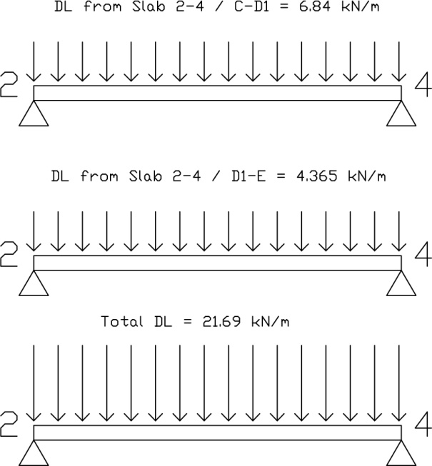

Live load on slab 2-4 / C-D1 [Two way slab]
Load is transferred to beam 2-4 / D1 in a trapezoidal form. Convert the trapezoidal load into UDL.
Live Load from slab 2-4 / C-D1 = Live load on slab x (L_{x}/2)
= 1.5 kN/m² x (3.8/2)
= 2.85 kN/m

Live load on slab 2-4 / D1-E [Two way slab]
Load is transferred to beam 2-4 / D1 in a trapezoidal form. Convert the trapezoidal load into UDL.
Live Load from slab 2-4 / D1-E = Live load on slab x (L_{x}/2)
= 2.0 kN/m² x (2.425/2)
= 4.85 kN/m

Total live load
Total for D1 = 2.85 kN/m + 4.85 kN/m
= 7.7 kN/m

Total Live Load Diagram
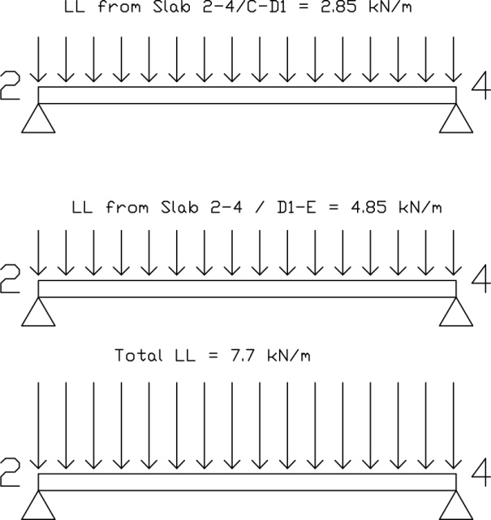
Ultimate Load
Apply factor 1.4 and 1.6 to dead load and live load respectively.

Dead Load D1 = 21.69 kN/m x 1.4
= 30.366 kN/m

Live Load D1 = 7.7 kN/m x 1.6
= 12.32 kN/m

Ultimate load D1 = 30.366 kN/m + 12.32 kN/m
= 42.686 kN/m

Ultimate Load Diagram
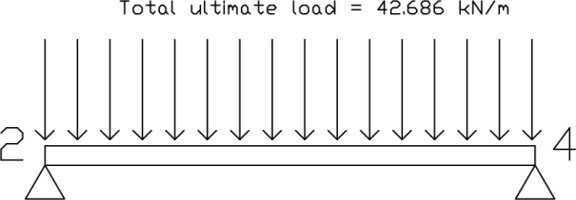

Reactions
ΣM_{D} = 0
Assuming that anti clockwise moment is positive, hence

0 = -(42.686x 5.95 x 5.95/2) + R_{Y} (5.95)
R_{Y} = 126.99 kN

ΣF_{y} = 0
R_{A} + R_{Y} – (39.4556 x 5.95) = 0
R_{D} = 107.77 kN

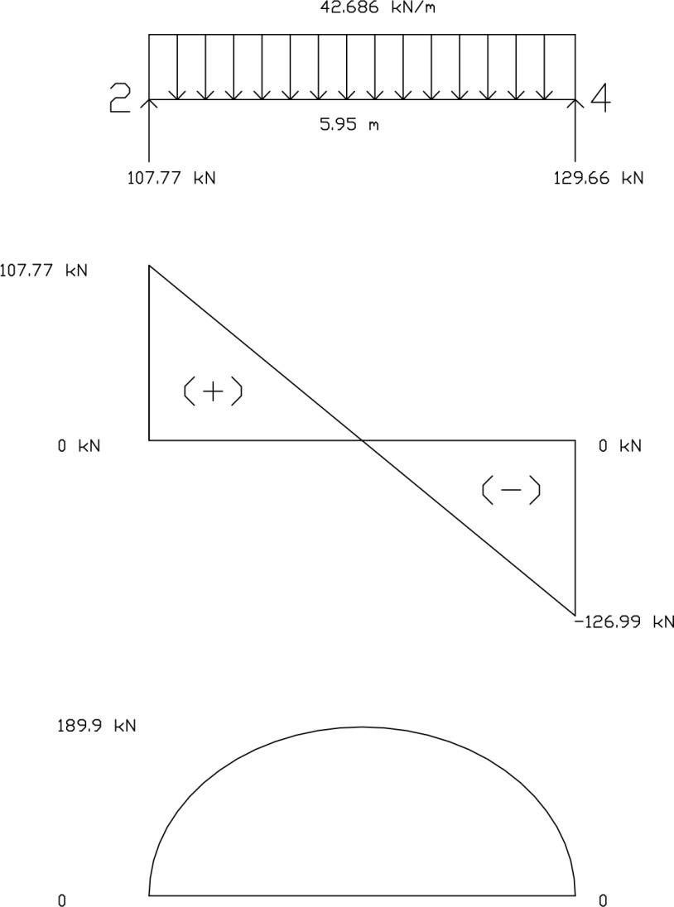

Beam Analysis Calculation
Ground Floor Beam, 4 / C-E
- Carries self-weight – Dead load
- Slab Dead Load & Live Load
- 2-4 / C-D1
- 2-4 / D1-E

- Beam self-weight = Beam size x concrete density
= 0.15 m x 0.30 m x 24 kN/m³
= 1.08 kN/m
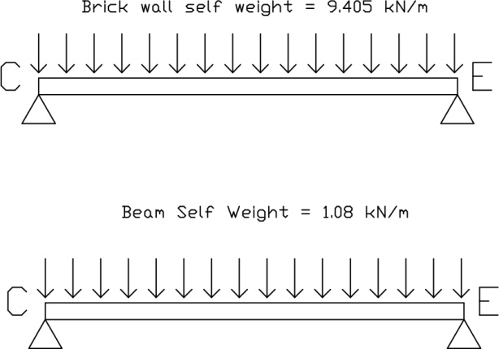
- Brick wall weight = Wall height x thickness x density
= 3.3 m x 0.15 m x 19 kN/m³
= 9.405 kN/m
Dead load on slab 2-4 / C-D1 [Two way slab]
Load is transferred to beam 4 / C-D1 in a triangular form. Convert the triangular load into UDL.
Dead Load from slab 2-4 / C-D1 = Dead load on slab x (L_{x}/2)
= 3.6 kN/m² x (3.8/2)
= 6.84 kN/m

Convert triangular load to UDL by applying a factor of 2/3.
Dead Load from slab 2-4 / C-D1 = 2/3 x 6.84
= 4.56 kN/m

Dead load on slab 2-4 / D1-E [Two way slab]
Load is transferred to beam 4 / C-D1 in a triangular form. Convert the triangular load into UDL.
Dead Load from slab 2-4 / D1-E = Dead load on slab x (L_{x}/2)
= 3.6 kN/m² x (2.425/2)
= 4.365 kN/m

Convert triangular load to UDL by applying a factor of 2/3.
Dead Load from slab 2-4 / D1-E = 2/3 x 4.365
= 2.91 kN/m

Total Dead Load
Total for 2-4 / C-D1= Beam self-weight + Brick wall weight + Dead load (2-4 / C-D1)
= 1.08 kN/m + 9.405 kN/m + 4.56 kN/m
= 15.045 kN/m
Total for 2-4 / D1-E = Beam self-weight + Brick wall weight + Dead load 2-4 / D1-E
= 1.08 kN/m + 9.405 kN/m + 2.91 kN/m
= 13.395 kN/m

Total Dead Load Diagram

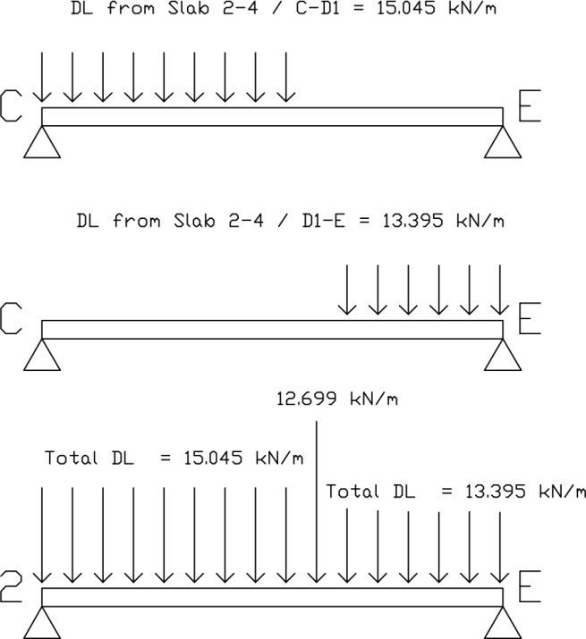

Live load on slab 2-4 / C-D1 [Two way slab]
Load is transferred to beam 2-4 / D1 in a triangular form. Convert the triangular load into UDL.
Live Load from slab 2-4 / C-D1 = Live load on slab x (L_{x}/2)
= 1.5 kN/m² x (3.8/2)
= 2.85 kN/m

Convert triangular load to UDL by applying a factor of 2/3.
Live Load from slab 2-4 / C-D1 = 2/3 x 2.85 kN/m
= 1.9 kN/m

Live load on slab 2-4 / D1-E [Two way slab]
Load is transferred to beam 2-4 / D1 in a triangular form. Convert the triangular load into UDL.
Live Load from slab 2-4 / D1-E = Live load on slab x (L_{x}/2)
= 2.0 kN/m² x (2.425/2)
= 2.425 kN/m

Convert triangular load to UDL by applying a factor of 2/3.
Live Load from slab 2-4 / D1-E = 2/3 x 2.425 kN/m
= 1.62 kN/m

Total Live Load Diagram
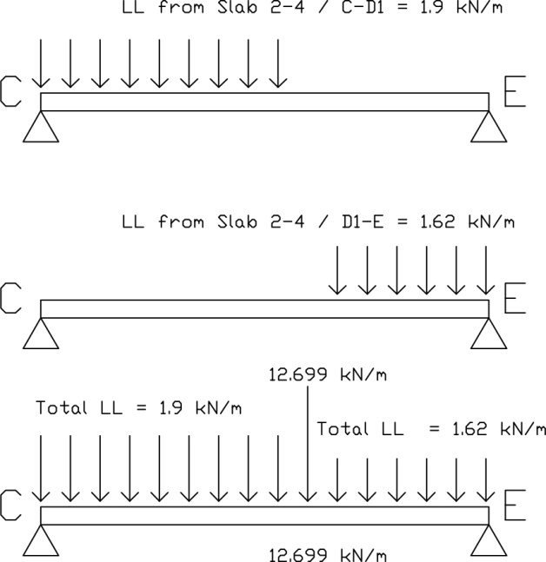

Ultimate Load
Apply factor 1.4 and 1.6 to dead load and live load respectively.

Dead Load 4/C-D1= 15.045 kN/m x 1.4
= 21.063 kN/m

Live Load 4/C-D1= 1.9 kN/m x 1.6
= 3.04 kN/m

Ultimate load 4/C-D1= 21.063 kN/m + 3.04 kN/m
= 24.103 kN/m

Dead Load 4/D1-E= 13.395 kN/m x 1.4
= 18.753 kN/m

Live Load 4/ D1-E = 1.62 kN/m x 1.6
= 2.592 kN/m

Ultimate load 4/D1-E= 18.753 kN/m + 2.592 kN/m
= 21.345 kN/m

Ultimate Load Diagram
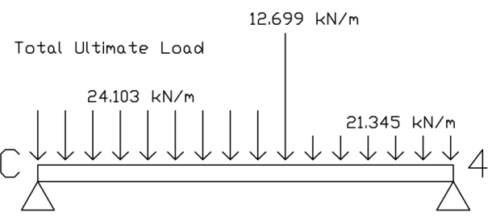

Reactions
ΣM_{D} = 0
Assuming that clockwise moment is positive, hence

0 = (24.103 x 3.8 x 3.8/2) + (126.99 x 3.8) + (21.345 x 2.425 x (3.8 + 2.425/2) - R_{Y} (5.95)
R_{Y} = 564.27/6.225 kN
= 90.65kN

ΣF_{y} = 0
R_{A} – (24.103 x 3.8) – 126.99 – 21.345(2.425) + 90.65 = 0
R_{A} = 179.6914 kN

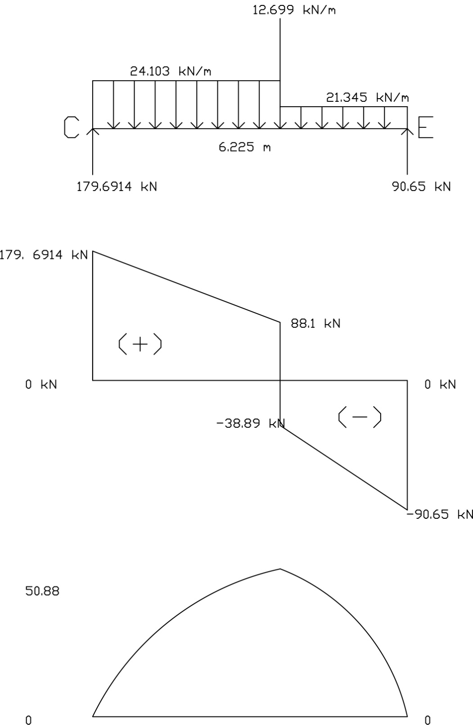

Be am Analysis Calculation
Ground Floor Beam, 2 / D-E
- Carries self-weight – Dead load
- Slab Dead Load & Live Load
- 2-4 / D1-E
- 2-4 / C-D1
- 1-2 / D-E

- Beam self-weight = Beam size x concrete density
= 0.15 m x 0.30 m x 24 kN/m³
= 1.08 kN/m
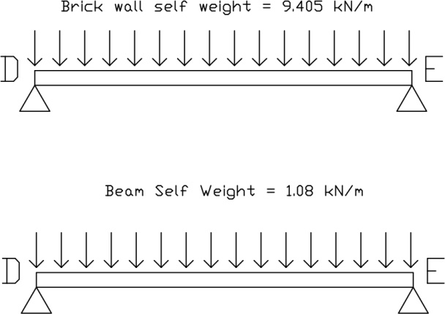
- Brick wall weight = Wall height x thickness x density
= 3.3 m x 0.15 m x 19 kN/m³
= 9.405 kN/m
Dead load on slab 2-4 / D1-E [Two way slab]
Load is transferred to beam 2 / D-E in a triangular form. Convert the triangular load into UDL.
Dead Load from slab 2-4 / D1-E = Dead load on slab x (L_{x}/2)
= 3.6 kN/m² x (2.425/2)
= 4.365 kN/m

Convert triangular load to UDL by applying a factor of 2/3.
Dead Load from slab 2-4 / D1-E = 2/3 x 4.365
= 2.91 kN/m

Dead load on slab 1-2 / D-E [Two way slab]
Load is transferred to beam 2 / D-E in a trapezoidal form. Convert the trapezoidal load into UDL.
Dead Load from slab 1-2 / D-E = Dead load on slab x (L_{x}/2)
= 3.6 kN/m² x (3.125/2)
= 5.625 kN/m

Dead load on slab 2-4 / C-D1 [Two way slab]
Load is transferred to beam 2 / D-E in a triangular form. Convert the triangular load into UDL.
Dead Load from slab 2-4 / C-D1 = Dead load on slab x (L_{x}/2)
= 3.6 kN/m² x (3.8/2)
= 6.84 kN/m

Convert triangular load to UDL by applying a factor of 2/3.
Dead Load from slab 2-4 / C-D1 = 2/3 x 6.84
= 4.56 kN/m

Total Dead Load
Total for 2/ D-D1= Beam self-weight + Brick wall weight + Dead load (1-2 / D-E) + Dead load (2-4/C-D1)
= 1.08 kN/m + 9.405 kN/m + 5.625 kN/m + 4.56 kN/m
= 20.67 kN/m

Total for 2 / D1-E = Beam self-weight + Brick wall weight + Dead load(1-2/D-E) + Dead load( 2-4 / D1-E)
= 1.08 kN/m + 9.405 kN/m + 5.625 kN/m + 2.91 kN/m
= 19.02 kN/m

Total Dead Load Diagram

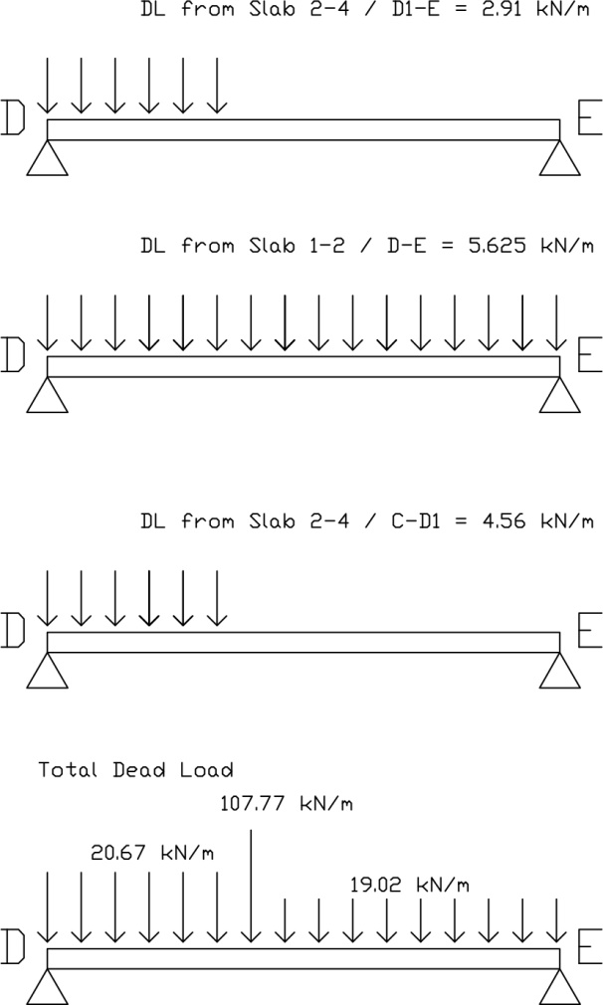

Live load on slab 2-4 / C-D1 [Two way slab]
Load is transferred to beam 2 / D-E in a triangular form. Convert the triangular load into UDL.
Live Load from slab 2-4 / C-D1 = Live load on slab x (L_{x}/2)
= 1.5 kN/m² x (3.8/2)
= 2.85 kN/m

Convert triangular load to UDL by applying a factor of 2/3.
Live Load from slab 2-4 / C-D1 = 2/3 x 2.85 kN/m
= 1.9 kN/m

Live load on slab 2-4 / D1-E [Two way slab]
Load is transferred to beam 2 / D-E in a triangular form. Convert the triangular load into UDL.
Live Load from slab 2-4 / D1-E = Live load on slab x (L_{x}/2)
= 2.0 kN/m² x (2.425/2)
= 2.425 kN/m

Convert triangular load to UDL by applying a factor of 2/3.
Live Load from slab 2-4 / D1-E = 2/3 x 2.425 kN/m
= 1.62 kN/m

Live load on slab 1-2 / D-E [Two way slab]
Load is transferred to beam 2 / D-E in a trapezoidal form. Convert the trapezoidal load into UDL.
Live Load from slab 1-2 / D-E = Live load on slab x (L_{x}/2)
= 2.0 kN/m² x (3.125/2)
= 3.125 kN/m

Total Live Load Diagram
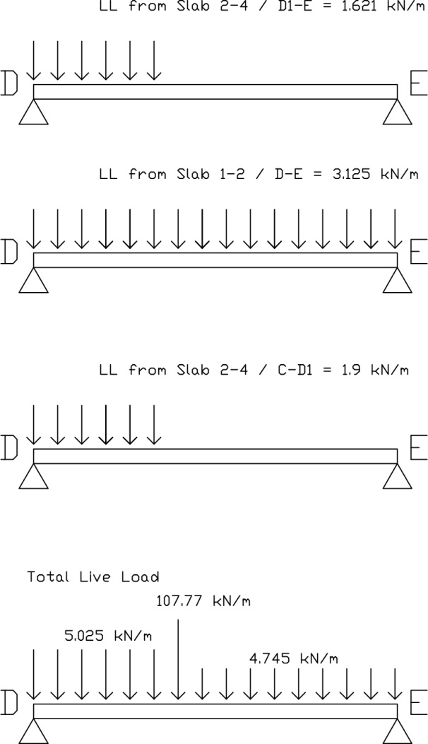

Ultimate Load
Apply factor 1.4 and 1.6 to dead load and live load respectively.

Dead Load D-D1/2= 20.67 kN/m x 1.4
= 28.958 kN/m

Live Load D-D1/2= 5.025 kN/m x 1.6
= 8.04 kN/m

Total ultimate load D-D1/2= 28.958 kN/m + 8.04 kN/m
= 36.978 kN/m

Dead Load 2/D1-E= 19.02 kN/m x 1.4
= 26.628 kN/m

Live Load 2/ D1-E = 4.745 kN/m x 1.6
= 7.592 kN/m

Total ultimate load 2/ D1-E = 26.628 kN/m + 7.592 kN/m
= 34.22 kN/m

Ultimate Load Diagram

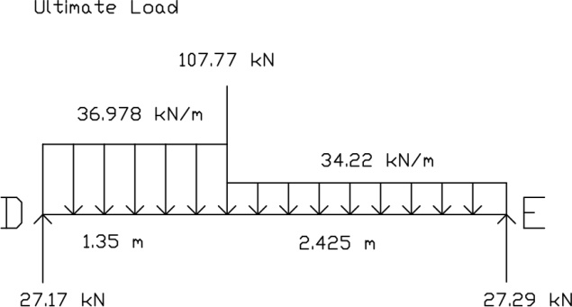
Reactions
ΣM_{D} = 0
Assuming that clockwise moment is positive, hence

0 = (35.978 x 1.35 x 1.35/2) + (107.77 x 1.35) + (34.22 x 2.425 x (2.425/2+1.35) - R_{Y} (3.775)
R_{Y} = 103.796kN

ΣF_{y} = 0
R_{A} – (36.978 x 1.35) – 107.77 – 34.22(2.425) + 103.796 = 0
R_{A} = 136.8778 kN

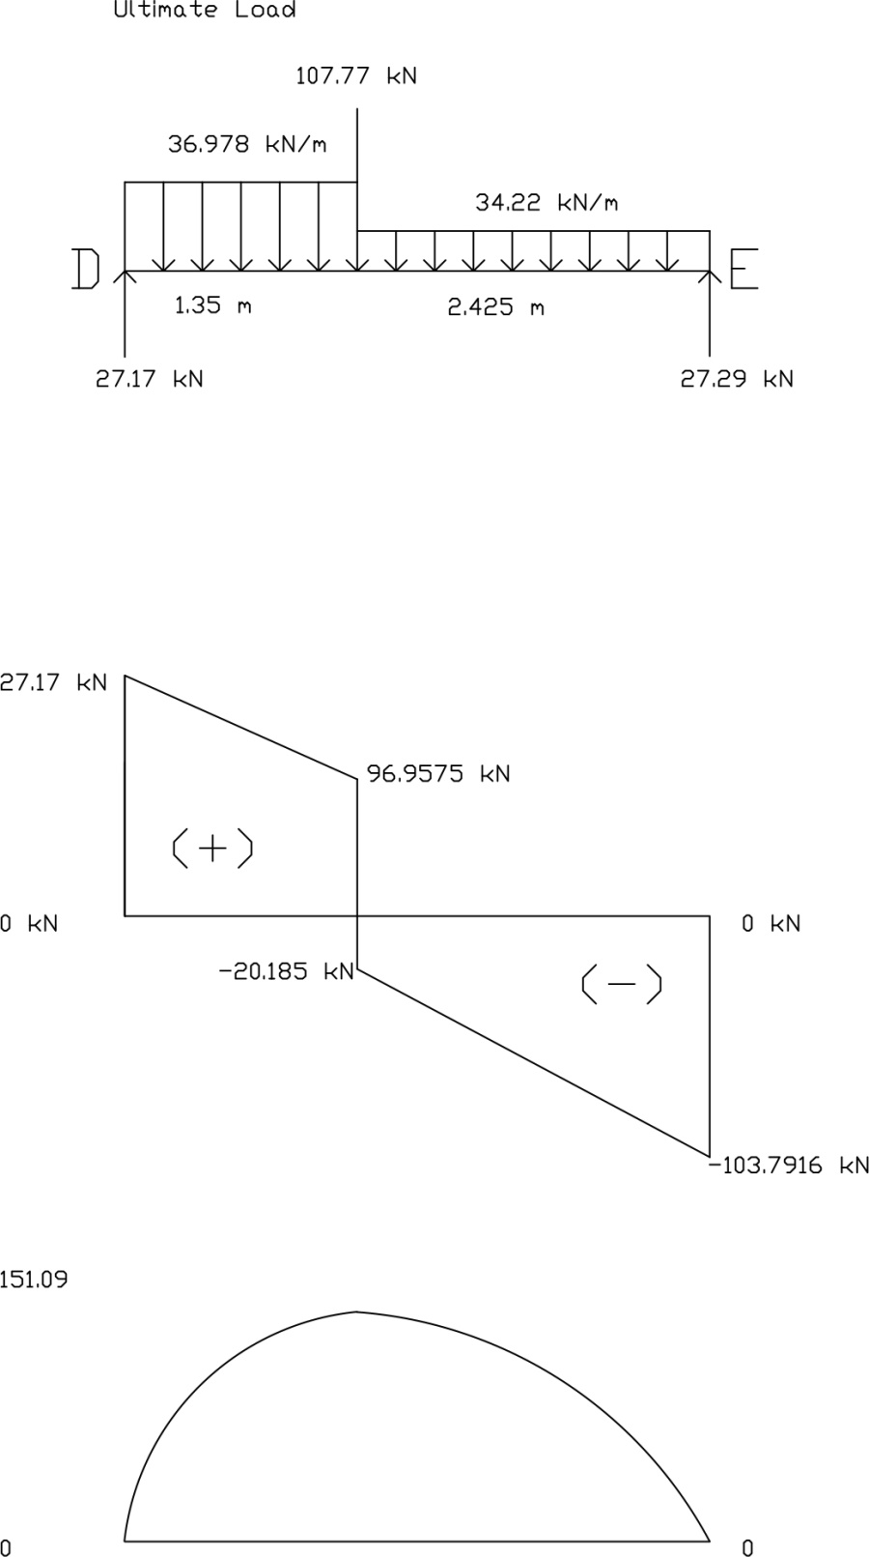
Beam Analysis Calculation
Ground Floor Beam, 2-3A / B
- Carries self-weight – Dead load
- Slab Dead Load & Live Load
- A-B / 2-3A
- B-C / 2-3A

- Beam self-weight = Beam size x concrete density
= 0.15 m x 0.30 m x 24 kN/m³
= 1.08 kN/m
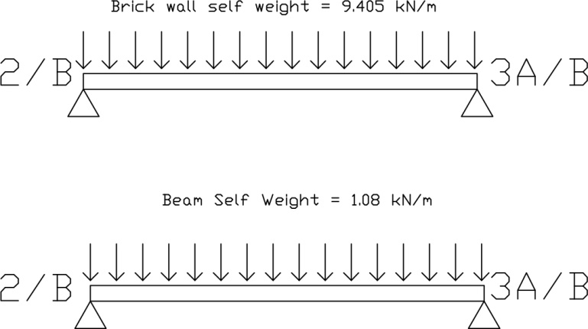
- Brick wall weight = Wall height x thickness x density
= 3.3 m x 0.15 m x 19 kN/m³
= 9.405 kN/m
Dead load on slab A-B / 2-3A [Two way slab]
Load is transferred to beam 2 / D-E in a triangular form. Convert the triangular load into UDL.
Dead Load from slab A-B / 2-3A= Dead load on slab x (L_{x}/2)
= 3.6 kN/m² x (2.975/2)
= 5.355 kN/m

Convert triangular load to UDL by applying a factor of 2/3.
Dead Load from slab A-B / 2-3A = 2/3 x 5.355
= 3.57 kN/m

Dead load on slab B-C/2-3A [Two way slab]
Load is transferred to beam 2 / D-E in a trapezoidal form. Convert the trapezoidal load into UDL.
Dead Load from slab 1-2 / D-E = Dead load on slab x (L_{x}/2)
= 3.6 kN/m² x (2.15/2)
= 3.87 kN/m

Total Dead Load
Total for 2-3A/B= Beam self-weight + Brick wall weight + Dead load (A-B/2-3A) + Dead load (B-C/2-3A)
= 1.08 kN/m + 9.405 kN/m + 3.57 kN/m + 3.87 kN/m
= 17.925 kN/m

Total Dead Load Diagram
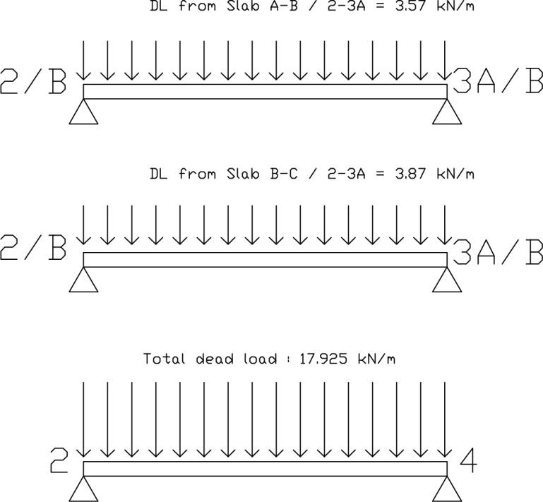

Live load on slab 2-3A / A-B [Two way slab]
Load is transferred to beam 2-3A / B in a triangular form. Convert the triangular load into UDL.
Live Load from slab 2-3A/A-B = Live load on slab x (L_{x}/2)
= 2.0 kN/m² x (2.975/2)
= 2.975 kN/m

Convert triangular load to UDL by applying a factor of 2/3.
Live Load from slab 2-3A/A-B = 2/3 x 2.975 kN/m
= 1.98 kN/m

Live load on slab 2-3A / B-C [Two way slab]
Load is transferred to beam 2-3A / B in a trapezoidal form. Convert the trapezoidal load into UDL.
Live Load from slab 2-3A / B-C = Live load on slab x (L_{x}/2)
=1.5 kN/m² x (2.15/2)
= 1.6125 kN/m

Total Live Load Diagram

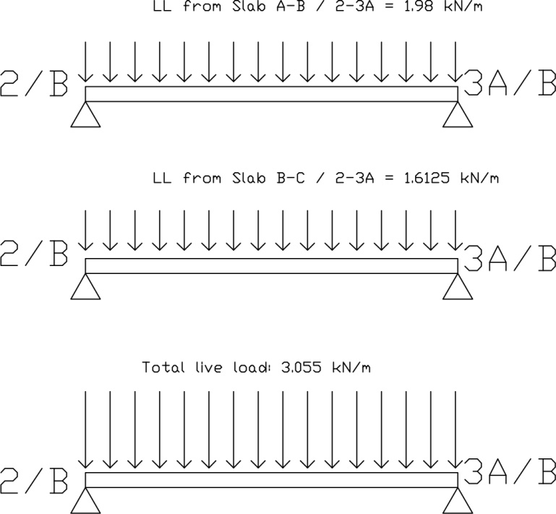
Ultimate Load
Apply factor 1.4 and 1.6 to dead load and live load respectively.

Dead Load 2-3A/B= 1.6635 kN/m x 1.4
= 23.289 kN/m

Live Load 2-3A/B= 3.5925 kN/m x 1.6
= 5.748 kN/m

Total ultimate load 2-3A/B = 23.289 kN/m + 5.748 kN/m
= 29.037 kN/m

Ultimate Load Diagram
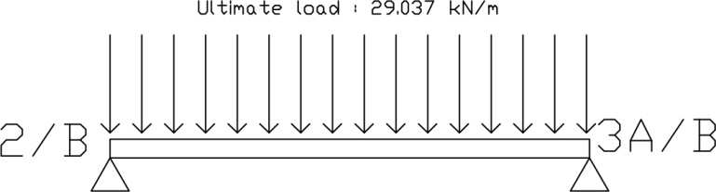

Reactions
ΣM_{D} = 0
Assuming that clockwise moment is positive, hence

0 = (29.037 x 2.975 x 2.975/2) - R_{Y} (2.975)
R_{Y} = 43.193kN

ΣF_{y} = 0
R_{A} – (29.037 x 2.975) + 43.193 = 0
R_{A} = 43.192 kN

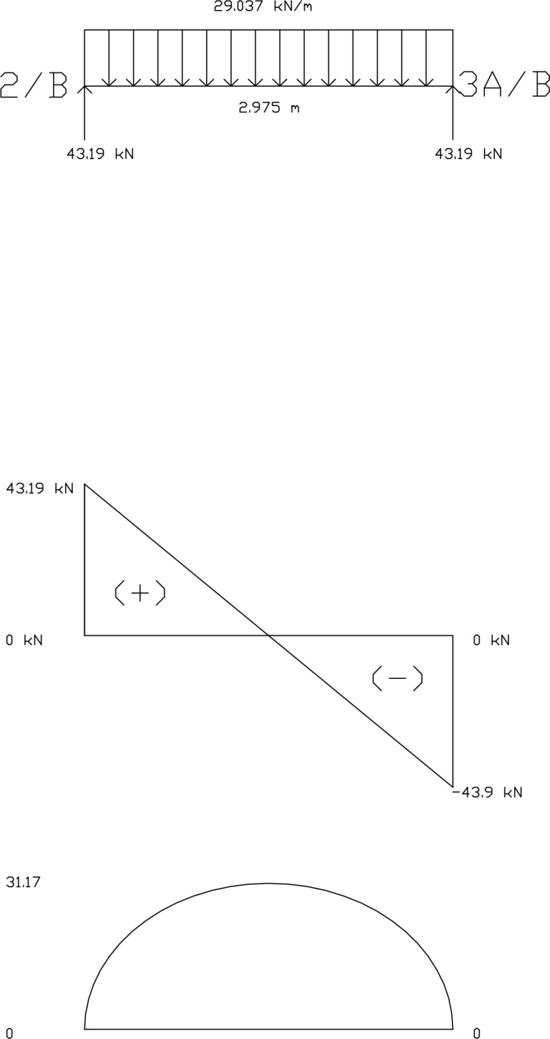

Beam Analysis Calculation
Ground Floor Beam, 3A / A-C
- Carries self-weight – Dead load
- Slab Dead Load & Live Load
- 3A / A-B
- 2-3A / B-C
- 3A-4 / A-C

- Beam self-weight = Beam size x concrete density
= 0.15 m x 0.30 m x 24 kN/m³
= 1.08 kN/m
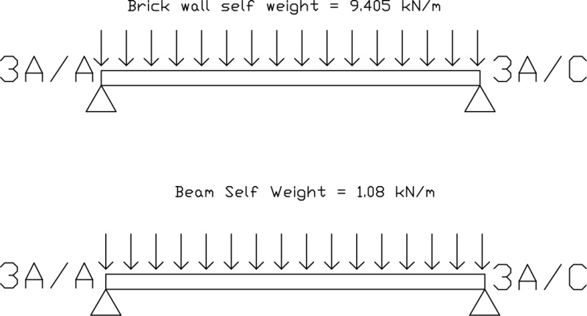
- Brick wall weight = Wall height x thickness x density
= 3.3 m x 0.15 m x 19 kN/m³
= 9.405 kN/m
Dead load on slab 3A/A-B [Two way slab]
Load is transferred to beam 3A/A-C in a trapezoidal form. Convert the trapezoidal load into UDL.
Dead Load from slab 3A/A-B = Dead load on slab x (L_{x}/2)
= 3.6 kN/m² x (2.925/2)
= 5.355 kN/m

Dead load on slab 2-3A/B-C [Two way slab]
Load is transferred to beam 3A/A-C in a triangular form. Convert the triangular load into UDL.
Dead Load from slab 2-3A/B-C = Dead load on slab x (L_{x}/2)
= 3.6 kN/m² x (2.15/2)
= 3.87 kN/m

Convert triangular load to UDL by applying a factor of 2/3.
Dead Load from slab 2-3A/B-C = 2/3 x 3.87
= 2.58 kN/m

Dead load on slab 3A-4/A-C [One way slab]
Load is transferred to beam 3A/A-C. Convert the load into UDL.
Dead Load from slab 3A-4/A-C = Dead load on slab x (L_{x}/2)
= 3.6 kN/m² x (2.975/2)
= 5.355 kN/m

Total Dead Load
Total for 3A/A-B = Beam self-weight + Brick wall weight + Dead load (3A/A-B) + Dead load (3A-4/A-C)
= 1.08 kN/m + 9.405 kN/m + 5.355 kN/m + 5.355 kN/m
= 21.195 kN/m

Total for 3A/B-C = Beam self-weight + Brick wall weight + Dead load(3A-4/A-C) + Dead load( 2-3A/B-C)
= 1.08 kN/m + 9.405 kN/m + 5.355 kN/m + 2.58 kN/m
= 18.42 kN/m

Total Dead Load Diagram

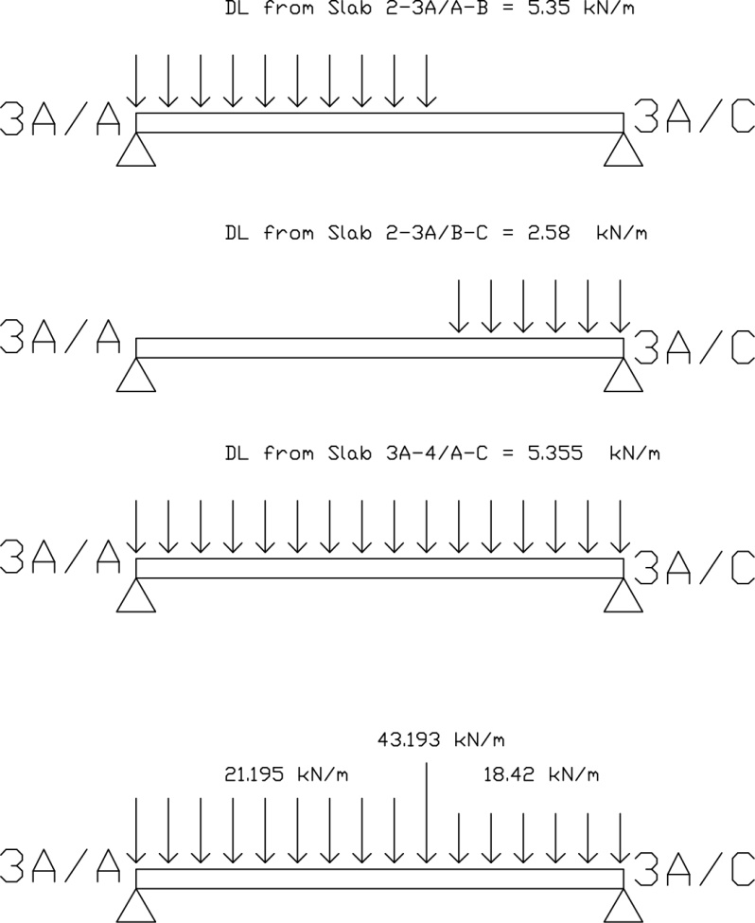

Live load on slab 3A-4/A-C [One way slab]
Load is transferred to beam 3A/A-C. Convert the load into UDL.
Live Load from slab 3A-4/A-C = Live load on slab x (L_{x}/2)
= 1.5 kN/m² x (2.975/2)
= 2.3125 kN/m

Live load on slab 2-3A/A-B [Two way slab]
Load is transferred to beam 3A/A-C in a trapezoidal form. Convert the trapezoidal load into UDL.
Live Load from slab 2-3A/A-B = Live load on slab x (L_{x}/2)
= 2.0 kN/m² x (2.975/2)
= 2.975 kN/m

Live load on slab 2-3A / B-C [Two way slab]
Load is transferred to beam 3A/A-C in a triangular form. Convert the trriangular load into UDL.
Live Load from slab 2-3A/B-C = Live load on slab x (L_{x}/2)
= 1.5 kN/m² x (2.15/2)
= 1.6125 kN/m

Convert triangular load to UDL by applying a factor of 2/3.
Dead Load from slab 2-3A/B-C = 2/3 x 1.6125
= 1.075 kN/m

Total live load
Total live load on beam 3A/A-B = 2.3125 + 2.975 kN/m
= 5.2975 kN/m
Total live load on beam 3A/B-C = 2.3125 + 1.075
= 3.30625 kN/m

Total Live Load Diagram
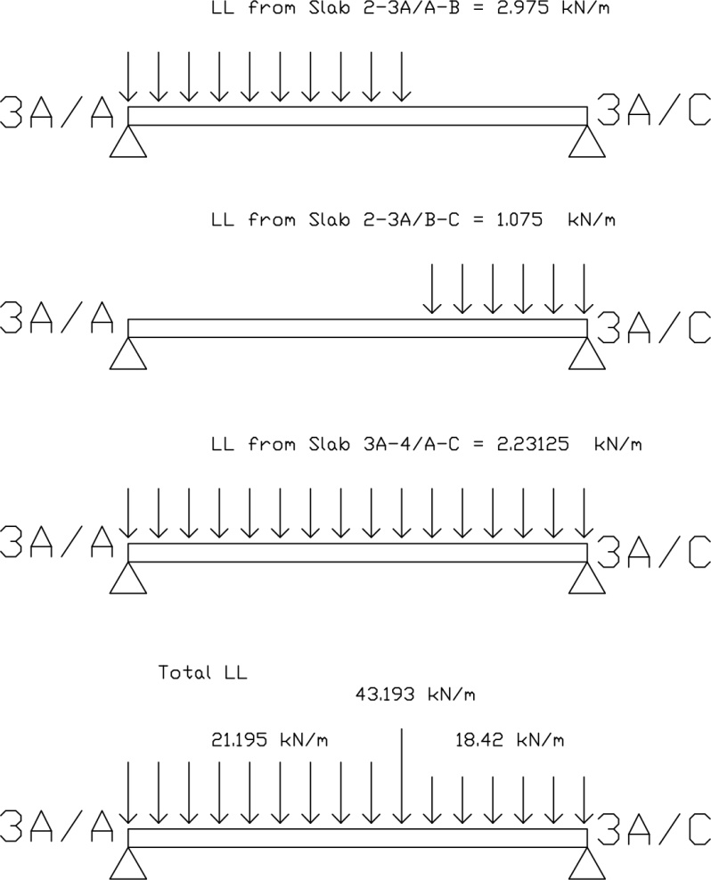

Ultimate Load
Apply factor 1.4 and 1.6 to dead load and live load respectively.

Dead Load 3A/A-B= 21.195 kN/m x 1.4
= 29.673 kN/m

Live Load 3A/A-B= 5.2875 kN/m x 1.6
= 8.46 kN/m

Total ultimate load 3A/A-B= 29.673 kN/m + 8.46 kN/m
= 38.133 kN/m

Dead Load 3A/B-C= 18.42 kN/m x 1.4
= 25.788 kN/m

Live Load 3A/B-C = 3.30625 kN/m x 1.6
= 5.29 kN/m

Total ultimate load 3A/B-C = 25.788 kN/m + 5.29 kN/m
= 31.078 kN/m

Ultimate Load Diagram
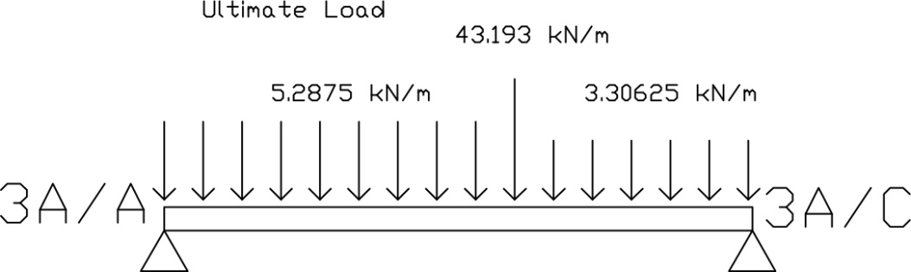

Reactions
ΣM_{D} = 0
Assuming that clockwise moment is positive, hence

0 = (38.133 x 4.1 x 4.1/2) + (43.193 x 4.1) + (31.078 x 2.15 x (4.1 + 2.15/2) ) - R_{Y} (6.25)
R_{Y} = 134.9408kN

ΣF_{y} = 0
R_{A} – (38.133 x 4.1) + 43.193 – (31.078 x 2.15) + 134.9408 = 0
R_{A} = 131.40875 kN

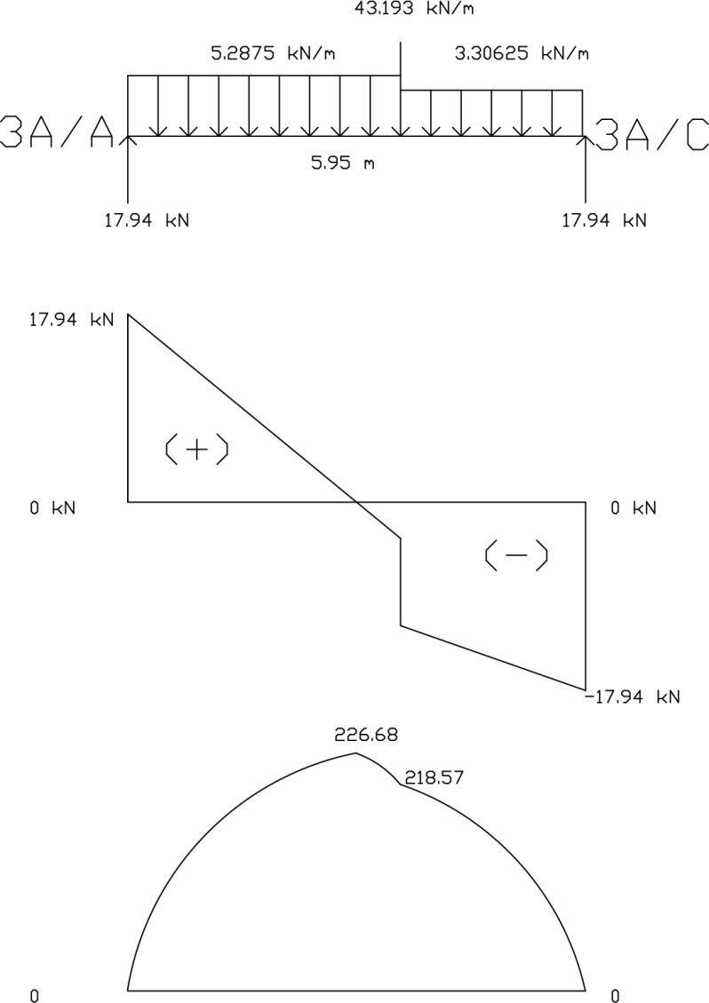
Beam Analysis Calculation
Ground Floor Beam, 2-4 / A
- Carries self-weight – Dead load
- Slab Dead Load & Live Load
- 2-3A/A-B
- 3A-4/ A-C

- Beam self-weight = Beam size x concrete density
= 0.15 m x 0.30 m x 24 kN/m³
= 1.08 kN/m
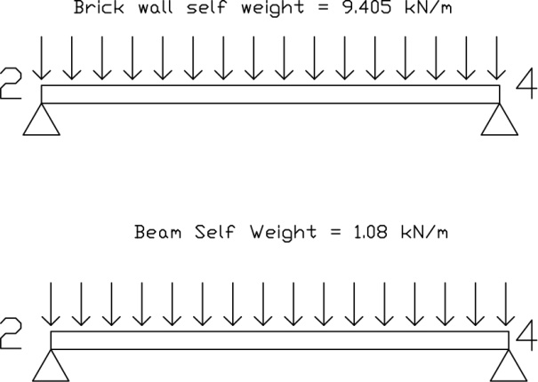
Brick wall weight = Wall height x thickness x density
= 3.3 m x 0.15 m x 19 kN/m³
= 9.405 kN/m
Dead load on slab 2-3A/A-B [Two way slab]
Load is transferred to beam 2-4/A in a triangular form. Convert the triangular load into UDL.
Dead Load from slab 2-3A/A-B = Dead load on slab x (L_{x}/2)
= 3.6 kN/m² x (2.975/2)
= 5.355 kN/m

Convert triangular load to UDL by applying a factor of 2/3.
Dead Load from slab 2-3A/A-B = 2/3 x 5.355
= 3.57 kN/m

Total Dead Load
Total for 2-3A/A= Beam self-weight + Brick wall weight + Dead load (2-3A/A-B)
= 1.08 kN/m + 9.405 kN/m + 3.57
= 14.055 kN/m

Total Dead Load Diagram

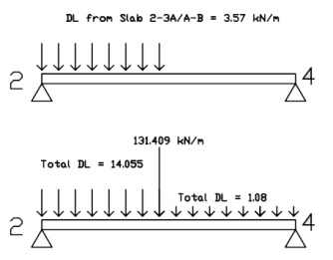

Live load on slab 2-3A/A-B [Two way slab]
Load is transferred to beam 2-4 / A in a triangular form. Convert the triangular load into UDL.
Live Load from slab 2-3A/A-B = Live load on slab x (L_{x}/2)
= 2.0 kN/m² x (2.975/2)
= 2.975 kN/m

Convert triangular load to UDL by applying a factor of 2/3.
Dead Load from slab 2-3A/A-B = 2/3 x 2.975
= 1.98 kN/m

Total Live Load Diagram
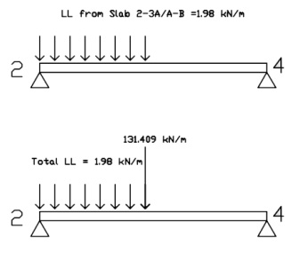
Ultimate Load
Apply factor 1.4 and 1.6 to dead load and live load respectively.

Dead Load 2-3/A= 14.055 kN/m x 1.4
= 19.677 kN/m

Live Load 2-3/A = 1.98 kN/m x 1.6
= 3.168 kN/m

Ultimate load 2-3/A= 19.677 kN/m + 3.168 kN/m
= 42.686 kN/m

Dead load 3A-4/A = 1.08 kN/m x 1.4
= 1.512 kN/m

Ultimate Load Diagram

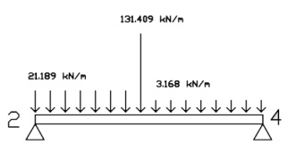
Reactions
ΣM_{D} = 0
Assuming that clockwise moment is positive, hence

0 = (21.189 x 2.975 x 2.975/2) + 131.409(2.975) + (3.168 x 2.975 x (2.975 + 2.975/2) ) - R_{Y} (5.95)
R_{Y} = 88.53 kN

ΣF_{y} = 0
R_{A} + R_{Y} – (21.189x 2.975 – 131.309 – 3.168x2.975) = 0
R_{A} =115.341 kN

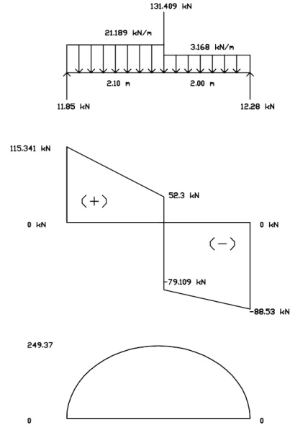

Column Analysis Calculation
Column 1/E
Slab area: 1.8875m x 2.6375 m = 4.978 m²
Roof Level
Dead load (slab) = 4.978 x 1.0
= 4.978 kN/m²
Dead load (beam)
Beam 1 = 1.8875 m x 1.08
= 2.0385 kN/m²
Beam E = 2.6365 x 1.08
= 2.8485 kN/m²
Ultimate Dead Load = (4.978 kN/m² + 2.0385 kN/m² + 2.8485 kN/m) x 1.4
= 13.811 kN/m²
Live load = 0.5 x 4.978
= 2.489 kN/m²
Ultimate live load = 2.489 x 1.6
= 3.9824 kN/m²
Roof Ultimate Load = 13.881 + 3.9824
= 17.7934 kN/m²
First Floor
Dead load (slab)
= 4.978 m² x 3.6 kN/m²
= 17.92 kN/m²

Dead load ( beam )
Beam 1 = 1.8875 m x 1.08
= 2.0385 kN/m²
Beam E = 2.6365 x 1.08
= 2.8485 kN/m²
Dead load (wall)
Wall 1 = 1.8875 m x 9.405 kN/m
= 17.75kN/m²
Wall E = 2.6375 x 9.405 kN/m
= 24.81 kN/m²
Ultimate dead load
= (17.92 + 2.04 + 2.85 + 17.75 + 24.81) x 1.4
= 91.518 kN/m²
Live load
= 2.0 x 4.978
= 9.956 kN/m²
Ultimate live load
= 9.956 x 1.6
= 15.93 kN/m²
First floor ultimate load
= 91.518 + 15.93
= 107.448 kN/m²
Ground floor
Dead load (slab)
= 4.978 m² x 3.6 kN/m²
= 17.92 kN/m²
Dead load ( beam )
Beam 1 = 1.8875 m x 1.08
= 2.0385 kN/m²
Beam E = 2.6365 x 1.08
= 2.8485 kN/m²
Dead load (wall)
Wall 1 = 1.8875 m x 8.55 kN/m
= 16.14kN/m²
Wall E = 2.635 x 8.55 kN/m
= 22.53 kN/m²
Ultimate dead load
= (17.92 + 2.039 + 2.85 + 16.14 + 22.53) x 1.4
= 61.48 kN/m²
Live load
= 3.0 x 4.978
= 14.934 kN/m²
Ultimate live load
= 14.934 x 1.6
= 23.89 kN/m²
Ground floor ultimate load
= 61.48 + 23.89
= 85.37 kN/m²

Total load acting on column 1/E
= 17.7934 + 107.448 + 85.37
= 210.61 kN/m²

Column 3/E
Area of floor slab = 4.5375 x 1.8875
= 8.56 m²
First floor
Dead load (slab)
8.56 x 3.6 = 30.816 kN/m²
Dead load ( brick wall )
2.6375 x 9.405 = 24.8 kN/m²
1.9 x 9.405 = 17.8695 kN/m²
1.8875 x 9.405 = 17.75 kN/m²
Dead load (beam)
2.6375 x 1.08 = 2.8485 kN/m²
1.9 x 1.08 = 2.052 kN/m²
1.8875 x 1.08 = 2.0385 kN/m²
Ultimate dead load
(30.816 + 24.8 + 17.8695 + 17.75 + 2.845 + 2.052 + 2.0385) x 1.4 = 137.4394 kN/m²
Live load
8.56 x 2.0 = 17.12 kN/m²
Ultimate live load
17.12 x 1.6 = 27.392 kN/m²
First Floor Total Ultimate Load
137.4394 + 27.392 = 164.83 kN/m²
Ground Floor
Dead load (slab)
8.56 x 3.6 = 30.816 kN/m²
Dead load( brick wall)
2.6375 x 8.55 = 22.55 kN/m²
1.9 x 8.55 = 16.245 kN/m²
1.8875 x 8.55 = 16.138 kN/m²
Dead load (beam)
2.6375 x 1.08 = 2.8485 kN/m²
1.9 x 1.08 = 2.052 kN/m²
1.8875 x 1.08 = 2.0385 kN/m²
Ultimate dead load
(30.816 + 22.55 + 16.245 + 16.138 + 2.8485 + 2.052 + 2.0385 ) x 1.4 = 129.8 kN/m²
Live load
Gym:
(1.9 x 1.8875) x 2.5 = 8.97 kN/m²
Lobby:
(2.6375 x 1.8875) x 2.0 = 9.96 kN/m²
Ultimate live load
(8.97 + 9.96) x 1.6 = 30.288 kN/m²
Ground Floor Total Ultimate load
129.7632 + 30.288 = 160.05 kN/m²
Total load acting on column 3/E
160.05 + 164.83 = 324.88 kN/m²

Column 4/E
Area of floor slab
= 3.6125 x 1.9
= 6.86 kN/m²
Roof level
Dead load (slab)
- x 6.86 = 6.86 kN/m²
Dead load (beam)
1.9 x 1.08 = 2.052 kN/m²
3.6125 x 1.08 = 3.9015 kN/m²
Ultimate dead load
(6.86 + 3.9015) x 1.4 = 15.0661 kN/m²
Live load
0.5 x 6.86 = 3.43 kN/m²
Ultimate live load
3.43 x 1.6 = 5.488 kN/m²
Roof level ultimate load
15.0661 + 5.488 = 20.5541 kN/m²
First Floor
Dead load (slab)
3.6 x 6.86 = 24.696 kN/m²
Dead load (beam)
1.9 x 1.08 = 2.052 kN/m²
3.6125 x 1.08 = 3.9015 kN/m²
Dead load (brick wall)
1.9 x 9.405 = 17.8695 kN/m²
3.6125 x 9.405 = 33.976 kN/m²
Total ultimate dead load
( 24.696 + 2.052 + 3.9015 + 17.8695 + 33.976) x 1.4 = 115.493 kN/m²
Ground floor
Dead load (slab)
3.6 x 6.86 = 24.696 kN/m²
Dead load (beam)
1.9 x 1.08 = 2.052 kN/m²
3.6125 x 1.08 = 3.9015 kN/m²
Dead load (brick wall)
1.9 x 8.55 = 16.245 kN/m²
3.6125 x 8.55 = 30.89 kN/m²
Ultimate dead load
(24.696 + 3.9015 + 2.052 + 16.245 + 30.89) x 1.4 = 108.9 kN/m²
Live load
2.5 x 6.86 = 17.15 kN/m²
Ultimate live load
17.15 x 1.6 = 27.44 kN/m²
Total ultimate live load
108.9 + 27.44 = 136.34 kN/m²
Total load acting on column 4/E
20.5541 + 136.34 + 137.4 = 294.3 kN/m²

